22.48: a) 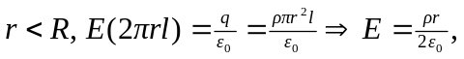 radially outward.
b)
c) 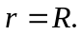the electric field for BOTH regions is 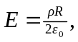so they are consistent.
d)
